Simple Linear Regression Examples, Problems, and Solutions
Simple linear regression allows us to study the correlation between only two variables:
- One variable (X) is called independent variable or predictor.
- The other variable (Y), is known as dependent variable or outcome.
and the simple linear regression equation is:
Y = Β₀ + Β₁X
Where:
X – the value of the independent variable,
Y – the value of the dependent variable.
Β₀ – is a constant (shows the value of Y when the value of X=0)
Β₁ – the regression coefficient (shows how much Y changes for each unit change in X)
Example 1:
You have to study the relationship between the monthly e-commerce sales and the online advertising costs. You have the survey results for 7 online stores for the last year.
Your task is to find the equation of the straight line that fits the data best.
The following table represents the survey results from the 7 online stores.
Online  Store | Monthly E-commerce Sales  (in 1000 s) | Online Advertising Dollars (1000 s)
1 | 368 | 1.7
2 | 340 | 1.5
3 | 665 | 2.8
4 | 954 | 5
5 | 331 | 1.3
6 | 556 | 2.2
7 | 376 | 1.3
We can see that there is a positive relationship between the monthly e-commerce sales (Y) and online advertising costs (X).
The positive correlation means that the values of the dependent variable (y) increase when the values of the independent variable (x) rise.
So, if we want to predict the monthly e-commerce sales from the online advertising costs, the higher the value of advertising costs, the higher our prediction of sales.
We will use the above data to build our Scatter diagram.
Now, let’ see how the Scatter diagram looks like:
Diagram 1:
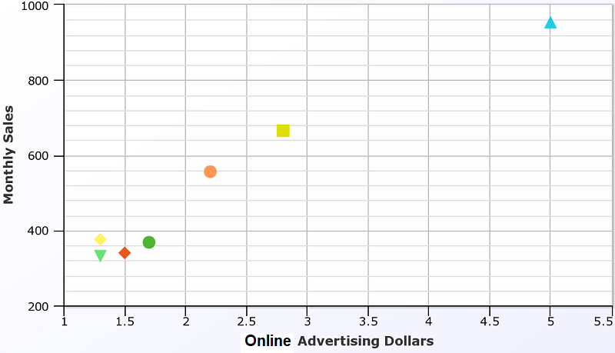
The Scatter plot shows how much one variable affects another. In our example, above Scatter plot shows how much online advertising costs affect the monthly e-commerce sales. It shows their correlation.
Let’s see the simple linear regression equation.
Y = Β₀ + Β₁X
Y= 125.8 + 171.5*X
Note: You can find easily the values for Β₀ and Β₁ with the help of paid or free statistical software, online linear regression calculators or Excel. All you need are the values for the independent (x) and dependent (y) variables (as those in the above table).
Now, we have to see our regression line:
Graph of the Regression Line:
Diagram 2
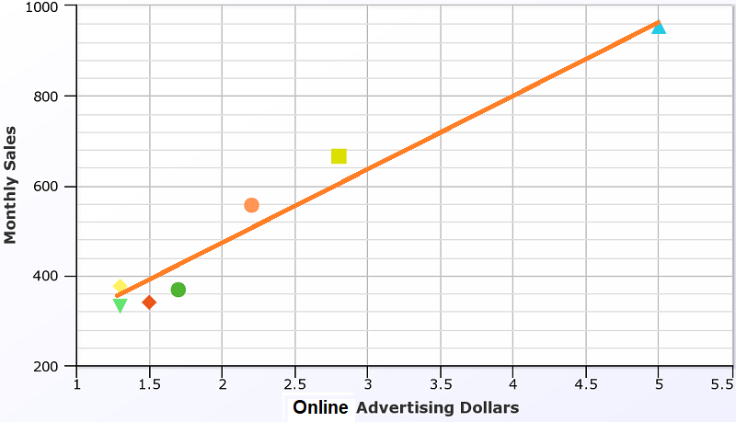
Linear regression aims to find the best-fitting straight line through the points. The best-fitting line is known as the regression line.
If data points are closer when plotted to making a straight line, it means the correlation between the two variables is higher. In our example, the relationship is strong.
The orange diagonal line in diagram 2 is the regression line and shows the predicted score on e-commerce sales for each possible value of the online advertising costs.
Interpretation of the results:
The slope of 171.5 shows that each increase of one unit in X, we predict the average of Y to increase by an estimated 171.5 units.
The formula estimates that for each increase of 1 dollar in online advertising costs, the expected monthly e-commerce sales are predicted to increase by $171.5.
This was a simple linear regression example for a positive relationship in business. Let’s see an example of the negative relationship.
Example 2:
You have to examine the relationship between the age and price for used cars sold in the last year by a car dealership company.
Here is the table of the data:
Car Age (in years) | Price (in dollars)
4 | 6300
4 | 5800
5 | 5700
5 | 4500
7 | 4500
7 | 4200
8 | 4100
9 | 3100
10 | 2100
11 | 2500
12 | 2200
Now, we see that we have a negative relationship between the car price (Y) and car age(X) – as car age increases, price decreases.
When we use the simple linear regression equation, we have the following results:
Y = Β₀ + Β₁X
Y = 7836 – 502.4*X
Let’s use the data from the table and create our Scatter plot and linear regression line:
Diagram 3:
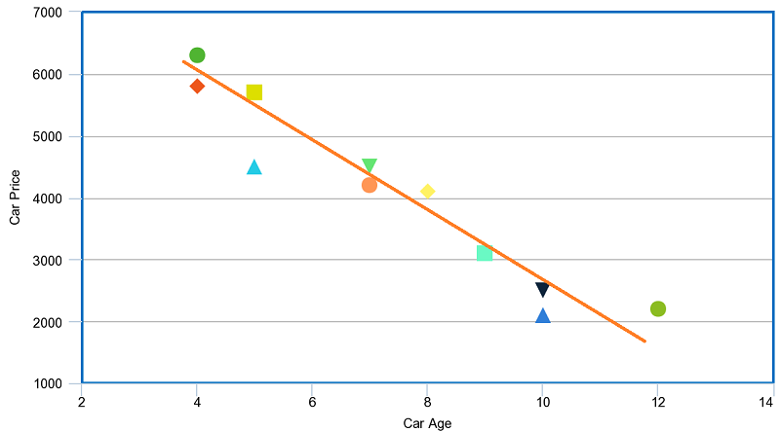
The above 3 diagrams are made with Meta Chart.
Result Interpretation:
With an estimated slope of – 502.4, we can conclude that the average car price decreases $502.2 for each year a car increases in age.
The above simple linear regression examples and problems aim to help you understand better the whole idea behind simple linear regression equation.

The Linear Regression Equation
Linear regression is a way to model the relationship between two variables. You might also recognize the equation as the slope formula. The equation has the form Y= a + bX, where Y is the dependent variable (that’s the variable that goes on the Y axis), X is the independent variable (i.e. it is plotted on the X axis), b is the slope of the line and a is the y-intercept.
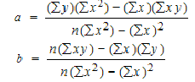
The first step in finding a linear regression equation is to determine if there is a relationship between the two variables. This is often a judgment call for the researcher. You’ll also need a list of your data in x-y format (i.e. two columns of data—independent and dependent variables).
Warnings:
- Just because two variables are related, it does not mean that one causes the other. For example, although there is a relationship between high GRE scores and better performance in grad school, it doesn’t mean that high GRE scores cause good grad school performance.
- If you attempt to try and find a linear regression equation for a set of data (especially through an automated program like Excel or a TI-83), you will find one, but it does not necessarily mean the equation is a good fit for your data. One technique is to make a scatter plot first, to see if the data roughly fits a line before you try to find a linear regression equation.

How to Find a Linear Regression Equation: Steps
Step 1: Make a chart of your data, filling in the columns in the same way as you would fill in the chart if you were finding the Pearson’s Correlation Coefficient.
Subject | Age x | Glucose Level y | xy | x² | y²
1 | 43 | 99 | 4257 | 1849 | 9801
2 | 21 | 65 | 1365 | 441 | 4225
3 | 25 | 79 | 1975 | 625 | 6241
4 | 42 | 75 | 3150 | 1764 | 5625
5 | 57 | 87 | 4959 | 3249 | 7569
6 | 59 | 81 | 4779 | 3481 | 6561
Σ | 247 | 486 | 20485 | 11409 | 40022
From the above table, Σx = 247, Σy = 486, Σxy = 20485, Σx2 = 11409, Σy2 = 40022. n is the sample size (6, in our case).
Step 2: Use the following equations to find a and b.
a = 65.1416
b = .385225
Click here if you want easy, step-by-step instructions for solving this formula.
Find a:
- ((486 × 11,409) – ((247 × 20,485)) / 6 (11,409) – 247²)
- 484979 / 7445
- =65.14
Find b:
- (6(20,485) – (247 × 486)) / (6 (11409) – 247²)
- (122,910 – 120,042) / 68,454 – 247²
- 2,868 / 7,445
- = .385225
Step 3: Insert the values into the equation.
y’ = a + bx
y’ = 65.14 + .385225x
That’s how to find a linear regression equation by hand!

